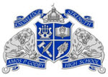
WHAT WE OFFER!
*Need Laminating?
*Need help with researching tips/methods?
*Need an interesting book to read?
Well, it’s only ONE THING we’re missing and that’s YOU! Come visit Godby Media Center where your needs will be met!
Hours of Operation: 7:30 a.m. to 2:30 p.m. We are also open before school and during lunch.
WHAT WE EXPECT OF OUR STUDENT BODY:
- Have a Yellow Media Center Pass to enter.
- Respect yourselves and others.
- Respect all school property.
- Clean up after yourself.
- Use inside voices.
- Return books on time.
- Read, Read, READ!!
Social Distancing and Health Awareness Protocol
For all students who enter the Media Center, proceed to the circulation desk and grab a disinfecting wipe. As students are leaving their table, they are to wipe down their area to prevent the transmission of germs from student to student.
For any student wanting to search for and check-out books, please proceed to the circulation desk to get a pair of gloves. This protocol will be to prevent transmission of germs from surfaces to students.
NEW ARRIVALS!!!
Come on over and browse our new arrivals collection. We’ve added brand new fiction, nonfiction, and graphic novels! You won’t be disappointed!
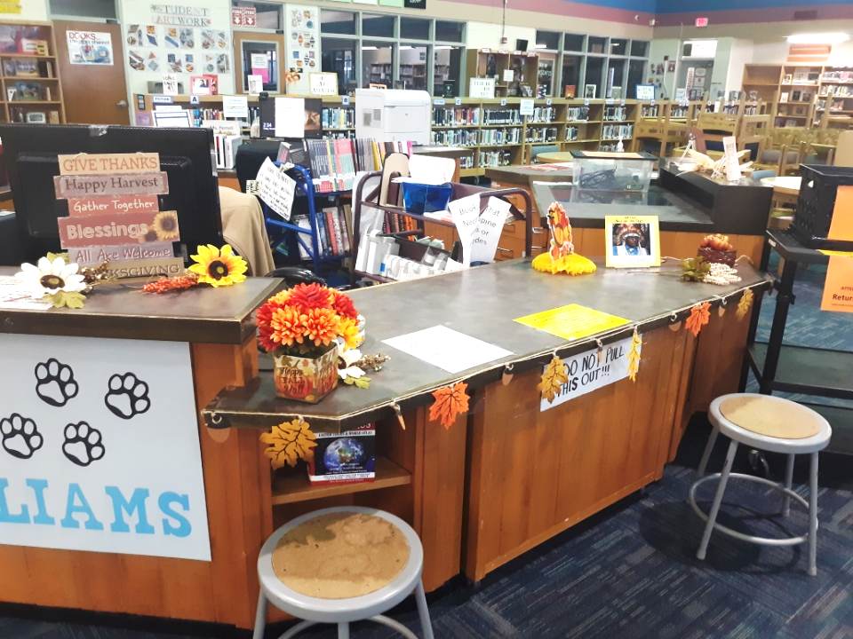
PREVIOUS AND CURRENT HIGHLIGHTS
Holiday Photo Backdrop!
Are your students in the holiday spirit? If so, send them to the Media Center to “Snap a Photo” of themselves with friends. Backdrops will be updated based on the upcoming holidays.
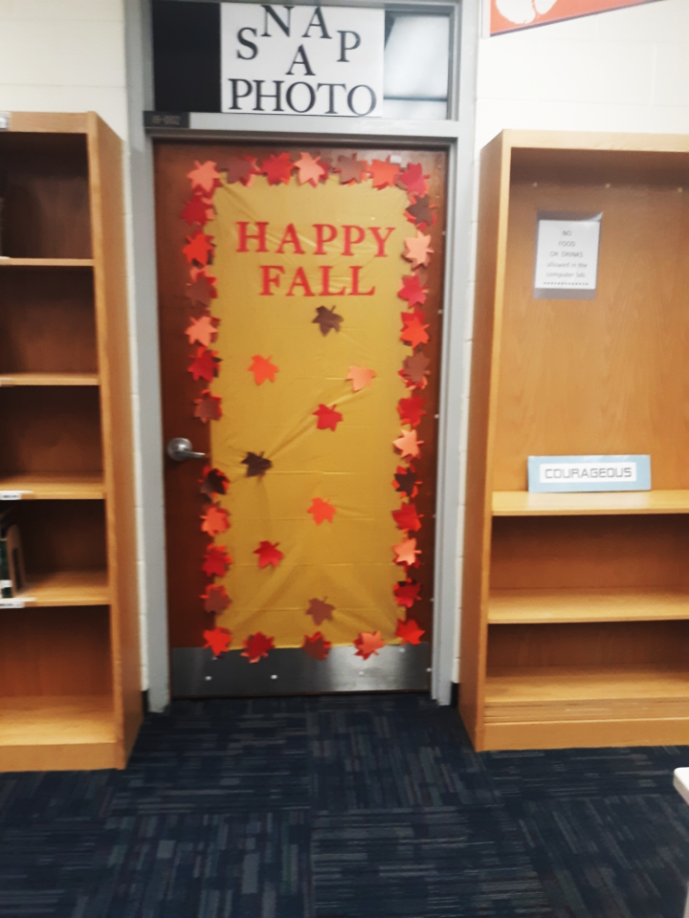
Total Number of New Arrivals Added to Catalog: 129
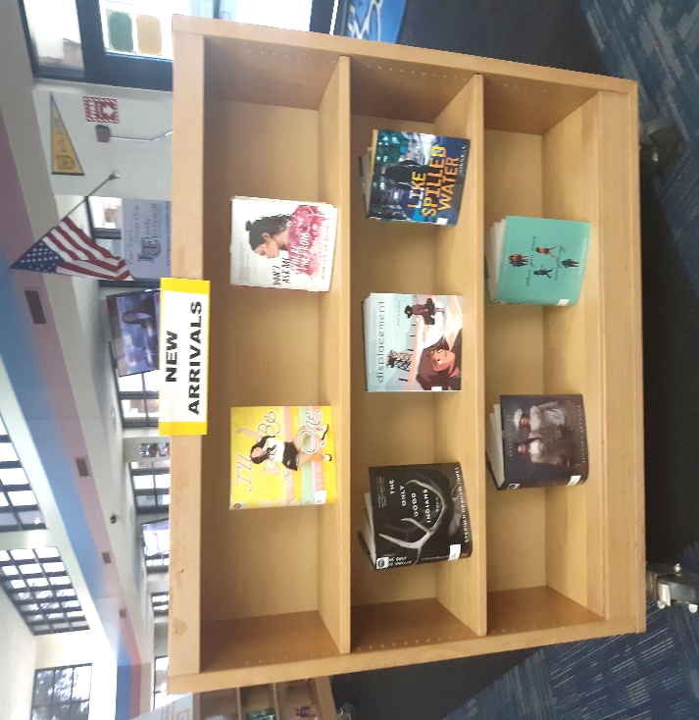
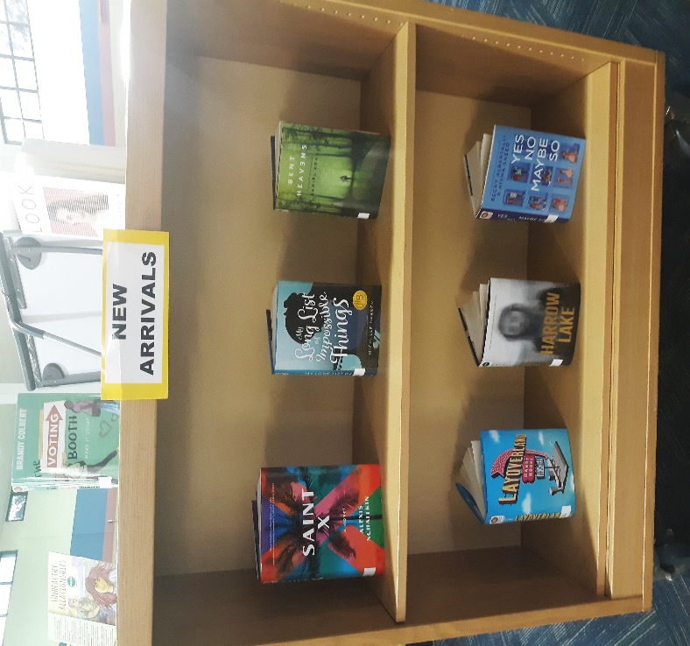
Ruth Bader Ginsburg Memorial
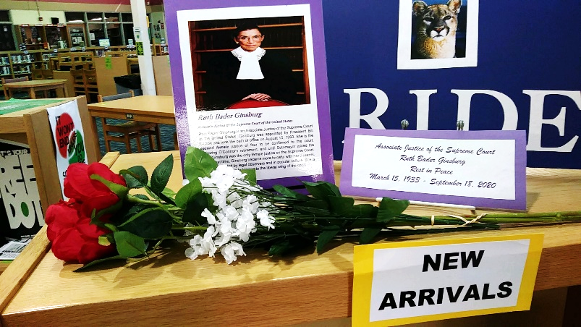
New Addition
The Media Center sends a Big THANK YOU to Ms. Shively for donating this timeless poster of Ruth Ginsburg to the Media Center. We appreciate you!
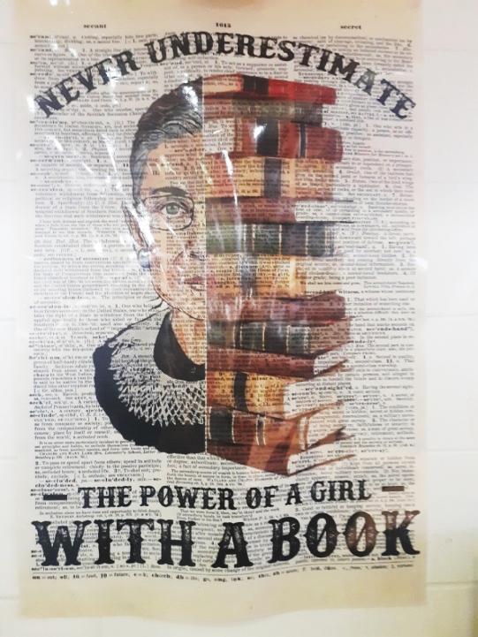
Cadet of the Week
The Media Center recognizes Godby's hardworking and dedicated cadets of the week!
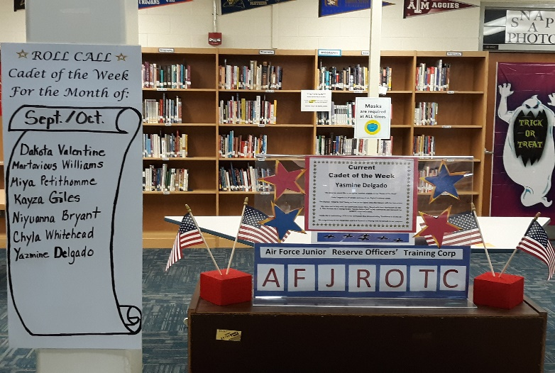
Total Number of Student ID Badges Created To Date: 498
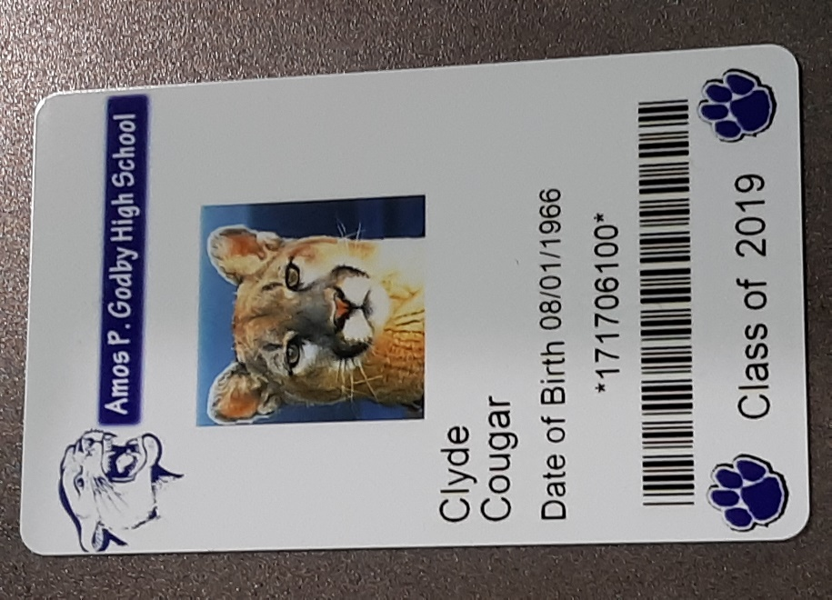
Fab 5
It is highly recommended through Leon County School District that we try our best to promote literacy school-wide during the school year. By using the FAB 5 (Phonemic Awareness, Phonics, Fluency, Comprehension, and Vocabulary) teachers can address the areas of struggle for our students in reading and writing.
Below is a website that offers more information on reading and writing literacy. There are also a multitude of resources on this website for teachers and parents that help with assisting students in this area.
Website: http://www.adlit.org/
UPCOMING!
*Prepping for FSA, ACT, SAT, ASVAB, or another assessment? Considering a Vocational Career?
Come to the Media Center and inquire about ways to prep for any big assessment. Cougar College and Career Corner is open for student use. Please stop by the circulation desk to discuss protocol for keeping all materials safe and sanitized for additional student use.
*Cougars on the Prowl
Cougars on the Prowl Display and Sports Highlight section is under construction. This display will include inspirational quotes and
Current student highlights in Godby sports.
*Getting to the Heart of Black History
To recognize Black History Month, we have decided to host an event titled “Getting to the Heart of Black History”. This event is an invitation only event for our students who practice upstanding citizenship daily around Godby’s campus. This event will test our student’s knowledge of black history in a very engaging and unique way. Students will also have the opportunity to win some cool prizes. So, feel free to stop by and check out the setup for this event on February 16th, 17th, and 18th. You won’t be disappointed.
*Book Bash
In April, the Media Center will be hosting our very first book bash. This event will give our students the opportunity to return overdue or lost books to the Media Center. Once a student has an account that is clear of any missing books, they will have the chance to win prizes. So teachers, start encouraging students to locate and return their overdue books. It’s never too late to get a great book back!
