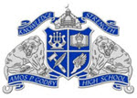
WHAT WE OFFER!
*Need laminating?
*Need to use a computer?
*Need to print?
*Need help with researching tips/methods?
*Need an interesting book to read?
Well, it’s only ONE THING we’re missing and that’s YOU! Come visit Godby Media Center where your needs will be met!
Hours of Operation: 7:30 a.m. to 2:30 p.m. We are also open before school and during lunch.
WHAT WE EXPECT OF OUR STUDENT BODY:
- Have a Yellow Media Center Pass to enter.
- Respect yourselves and others.
- Respect all school property.
- Clean up after yourself.
- Use inside voices.

- Return books on time.
- Read, Read, READ!!

Green Dot Spot is here!!!
Do you have students that are interested in Green Dot Bystander training? If so, send your students over to the Green Dot Spot in the Media Center to sign up!
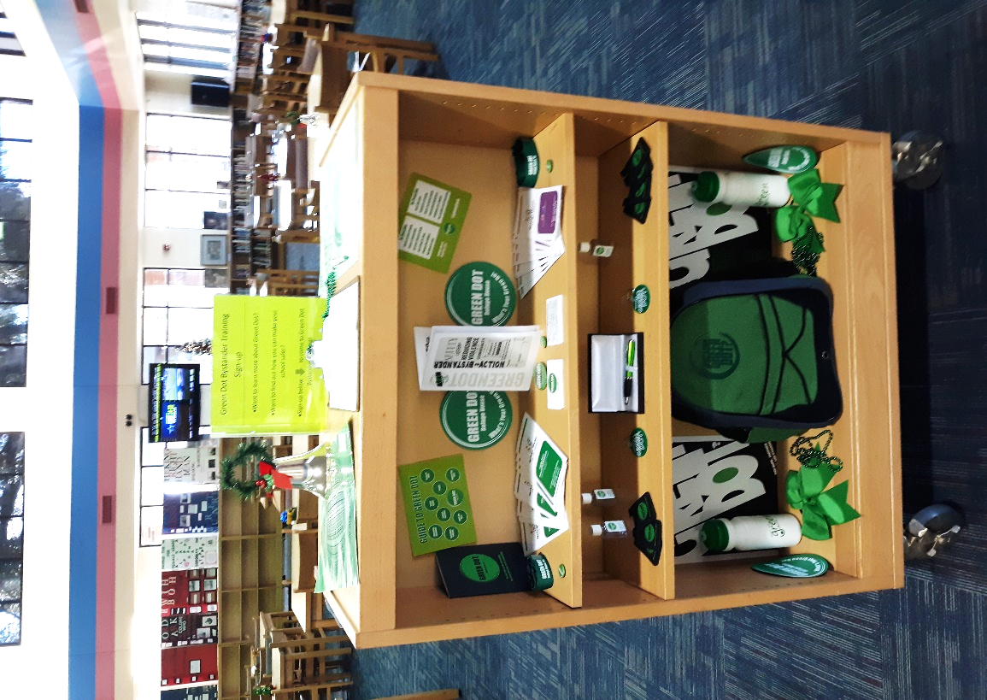
Literacy Week Celebration was a HUGE Success!
Thank you to all who participated in our week- long events to celebrate Literacy! We’re already looking forward to festivities for next year.
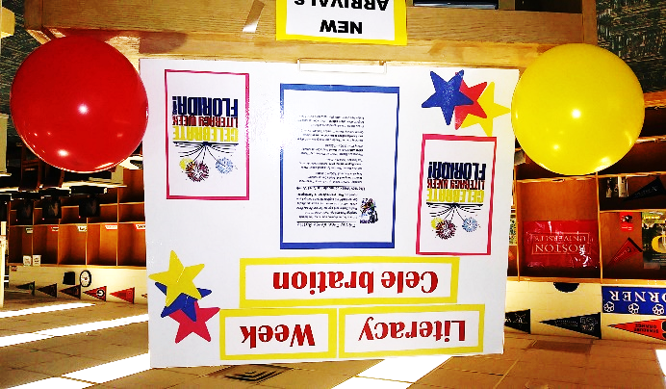
Black History Month Celebration!
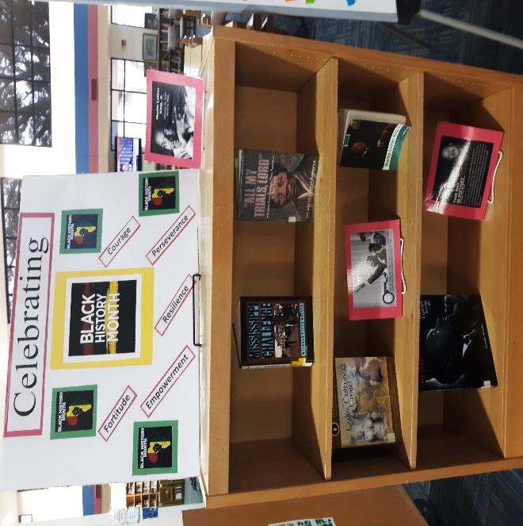
African American Heritage Display!
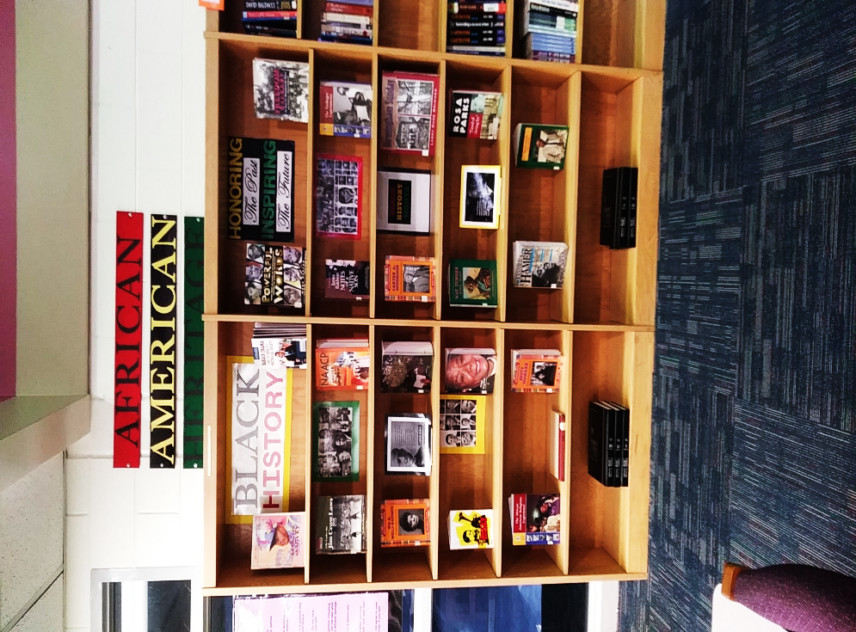
Quick Facts:
While visiting the Media Center, students will have the opportunity to learn quick facts about various Heritages, Cultures, and Historical Figures.
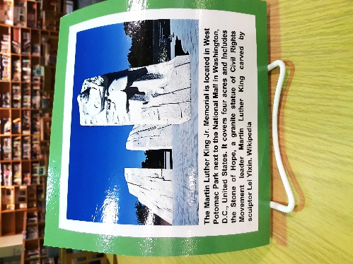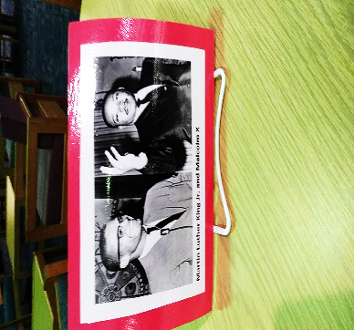
Martin Luther King Jr. Celebration!
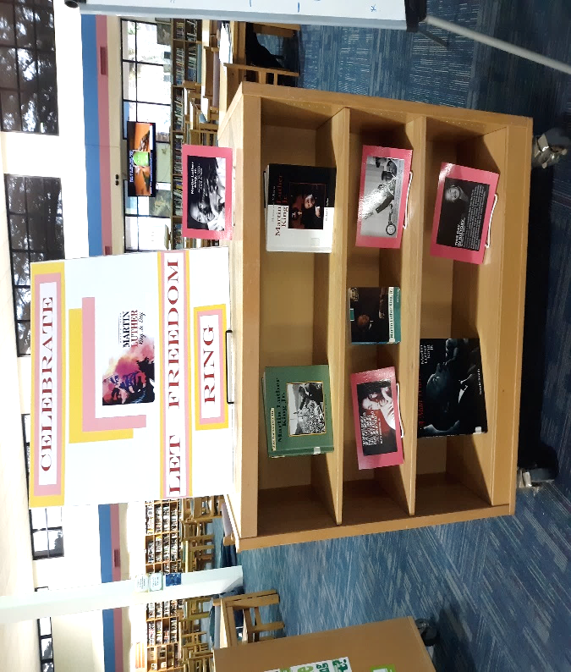

Holiday Photo Backdrop!
Are your students in the holiday spirit? If so, send them to the Media Center to “Snap a Photo” of themselves with friends. Backdrops will be updated based on the upcoming holidays.
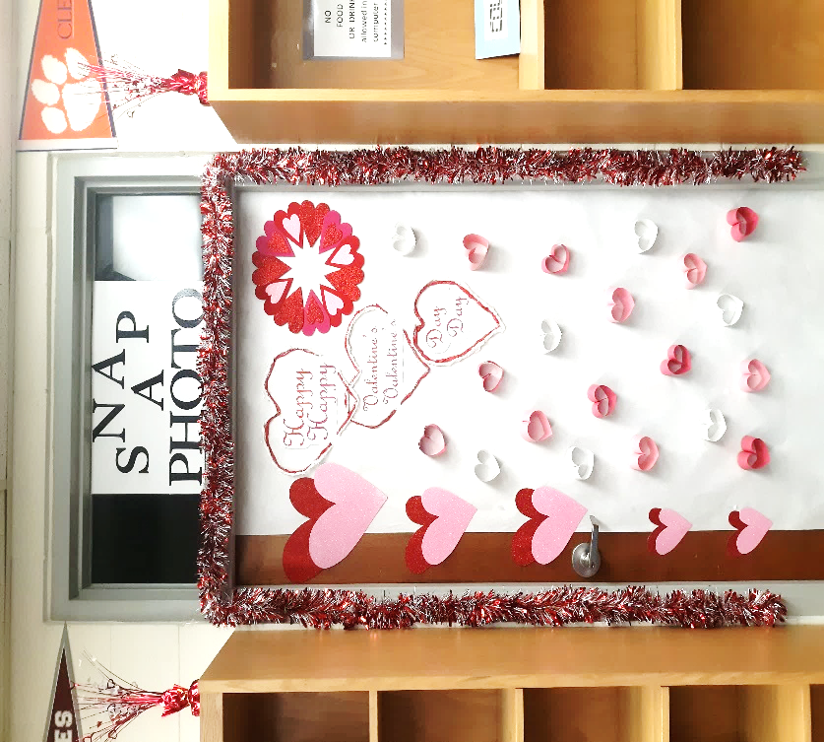

CURRENT STATISTICS AND HIGHLIGHTS!
Top Circulated Book this Quarter
- Thirteen Reasons Why: A Novel by Jay Asher
High school student Clay Jensen receives a box in the mail containing seven cassette tapes recorded by his crush, Hannah Baker, who committed suicide, and spends a bewildering and heartbreaking night crisscrossing their town, listening to Hannah's voice recounting the events leading up to her death.
Total Number of Student ID Badges Created to Date: 569
Students can come to the Media Center to get their student ID badge before school, 7:00-7:20am, during class (with a yellow media center pass), and after school 1:50-2:20pm.
Total Number of Students Trained on Gale Database: 174
Total Number of Circulations to Date: 1,556

Grade level Shout-Out: Congrats again 11th Grade for the most checked out books for third Quarter! Awesome job!
Teacher Shout-Out: Congrats again Mrs. Poey for the most students to check out books for Third Quarter! Way to go!
Student Sign-In By Day of Week

Total Number of Sign-Ins to Date: 3,847
UPCOMING!
*Want to learn more about different Heritages, their customs, and their traditions? Come by and visit our Hispanic, Native American, Italian, Asian, Irish, and African American Heritage displays around the Media Center.

