WHAT WE OFFER!
*Need Laminating?
*Need to use a computer?
*Need to print?
*Need help with researching tips/methods?
*Need an interesting book to read?
Well, it’s only ONE THING we’re missing and that’s YOU! Come visit Godby Media Center where your needs will be met!
Hours of Operation: 7:30 a.m. to 2:30 p.m. We are also open before school and during lunch.
WHAT WE EXPECT OF OUR STUDENT BODY:
- Have a Yellow Media Center Pass to enter.
- Respect yourselves and others.
- Respect all school property.
- Clean up after yourself.
- Use inside voices.
- Return books on time.
- Read, Read, READ!!
NEW ARRIVALS!!!
“We have to CHANGE BOOKS if we want BOOKS to CHANGE us!”
Come on over and browse our new arrivals collection. We’ve added brand new fiction, nonfiction, and graphic novels! You won’t be disappointed!
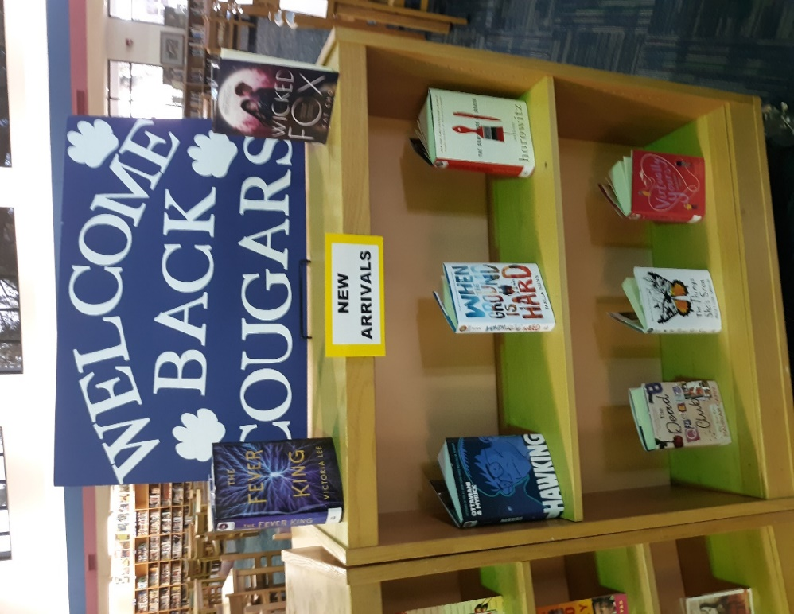
CURRENT STATISTICS AND HIGHLIGHTS!
Top 5 Circulated Books
- Batman: Nightwalker
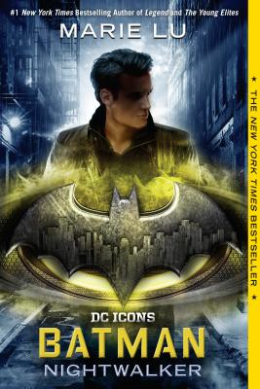
Before he was Batman, he was Bruce Wayne, a reckless boy willing to break the rules for a girl who may be his worst enemy. This second novel in the new DC Icons series is penned by #1 "New York Times"-bestselling author Lu. The first printing of each DC Icons novel includes a limited-edition poster. Consumable.
- Flush
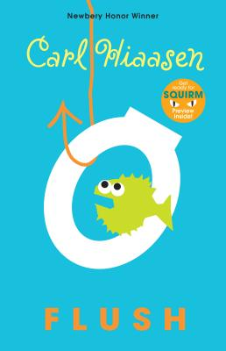
Noah's dad is sure that the owner of the Coral Queen casino boat is flushing raw sewage into the harbor--which has made taking a dip at the local beach like swimming in a toilet. He can't prove it though, and so he decides that sinking the boat will make an effective statement. Right. The boat is pumped out and back in business within days and Noah's dad is in the local lock-up.
Now Noah is determined to succeed where his dad failed. He will prove that the Coral Queen is dumping illegally . . . somehow.
- House of Ash
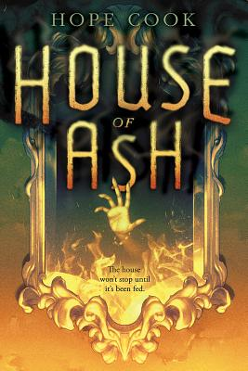
When seventeen-year-old Curtis begins hearing voices, he fears he is schizophrenic like his father, but soon he encounters Mila, a girl from the 1890s who lives in a cursed mansion and needs his help.
- The Impossible Knife of Memory
A searing look at the effects of post-traumatic stress on soldiers and their families, seen through the eyes of teenage Hayley. Hayley is struggling - struggling to make sure her ex-army dad shows up to work, struggling to avoid her stepmother, struggling not to fall in love with Finn, who really seems to get her. Struggling to forget the past. But some memories run too deep, and soon the cracks start to show. Stunning, hard-hitting fiction from an award-winning writer.
- Monster
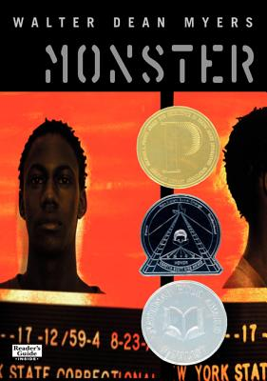
Sometimes I feel like I have walked into the middle of a movie. Maybe I can make my own movie. The film will be the story of my life. No, not my life, but of this experience. I'll call it what the lady who is the prosecutor called me. Monster.
Total Number of Circulations
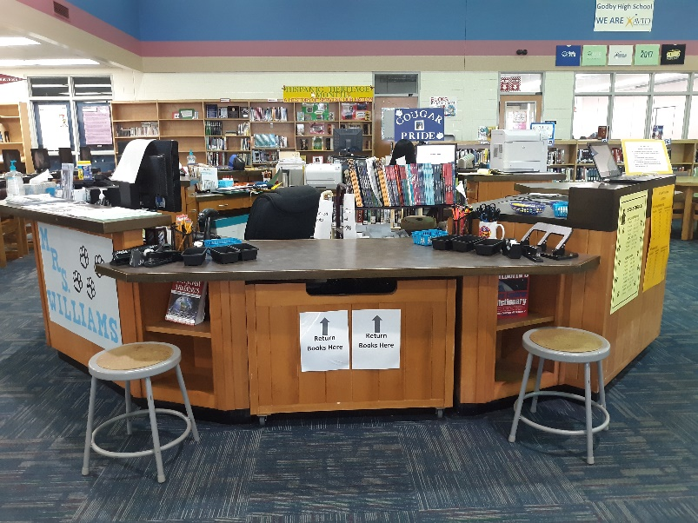
- Grade 9- 141
- Grade 10- 188
- Grade 11- 291
- Grade 12- 37
Total Circulations: 657

Grade level shout-out: Congrats 11th Grade for the most checked out books for First Quarter!
Teacher shout-out: Congrats Ms. Poey for the most students to check out books for First Quarter!
Hispanic Heritage Month
Don’t know much about Hispanic heritage, culture, or traditions? Come by and check out our Hispanic book collection!
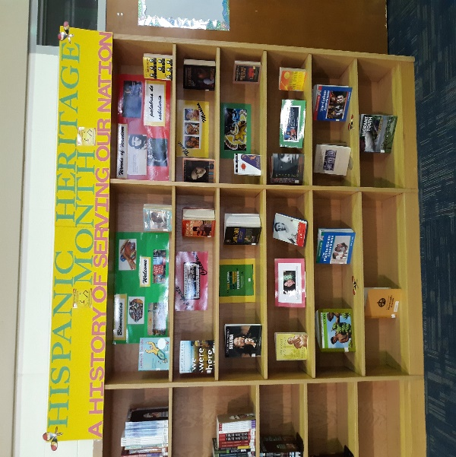

9-11-2001 Memorial
We shall never forget.
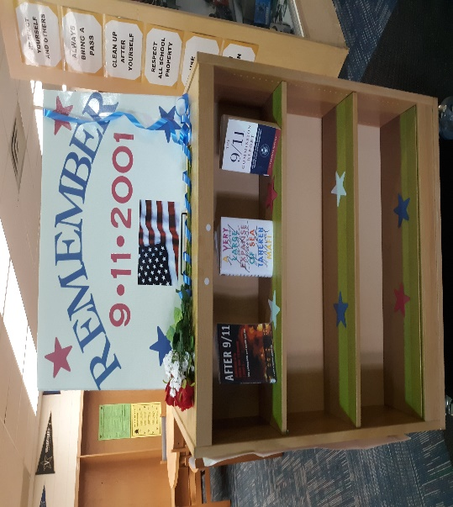
Cougarific Encouragement!
We advertise positivity and uniqueness in the Media Center because we want every student to know they matter and that they are capable of achieving anything they set their minds to.
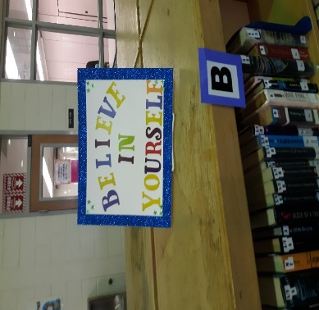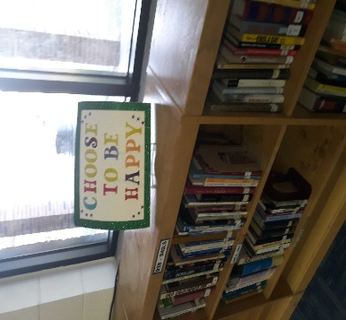
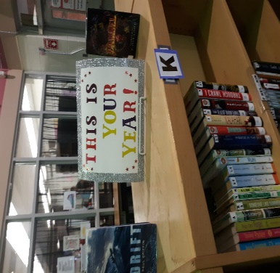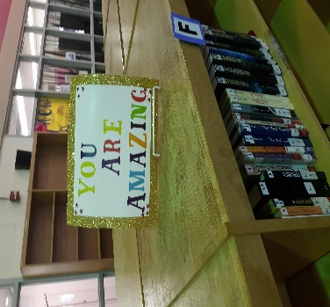
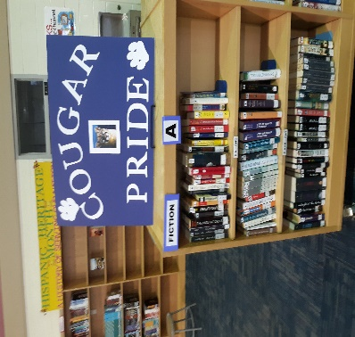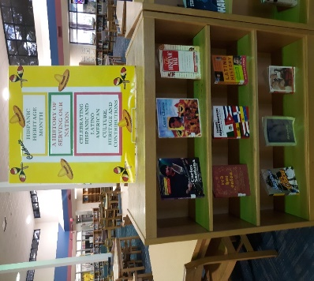
UPCOMING!
*Looking for researching tips/methods?
Gale Database whole class trainings will begin 2nd 9 weeks. (Email to signup: williamsl32@leonschools.net)
*Prepping for FSA, ACT, SAT, ASVAB, or another assessment? Considering a Vocational Career?
Cougar College and Career Corner will be set-up and ready to go during the 2nd 9 weeks. Feel free to stop by to check it out!

