WHAT WE OFFER!
*Need Laminating?
*Need to use a computer?
*Need to print?
*Need help with researching tips/methods?
*Need an interesting book to read?
Well, it’s only ONE THING we’re missing and that’s YOU! Come visit Godby Media Center where your needs will be met!
Hours of Operation: 7:30 a.m. to 2:30 p.m. We are also open before school and during lunch.
WHAT WE EXPECT OF OUR STUDENT BODY:
- Have a Yellow Media Center Pass to enter.
- Respect yourselves and others.
- Respect all school property.
- Clean up after yourself.
- Use inside voices.
- Return books on time.
- Read, Read, READ!!
NEW ARRIVALS!!!
“We have to CHANGE BOOKS if we want BOOKS to CHANGE us!”
Come on over and browse our new arrivals collection. We’ve added brand new fiction, nonfiction, and graphic novels! You won’t be disappointed!
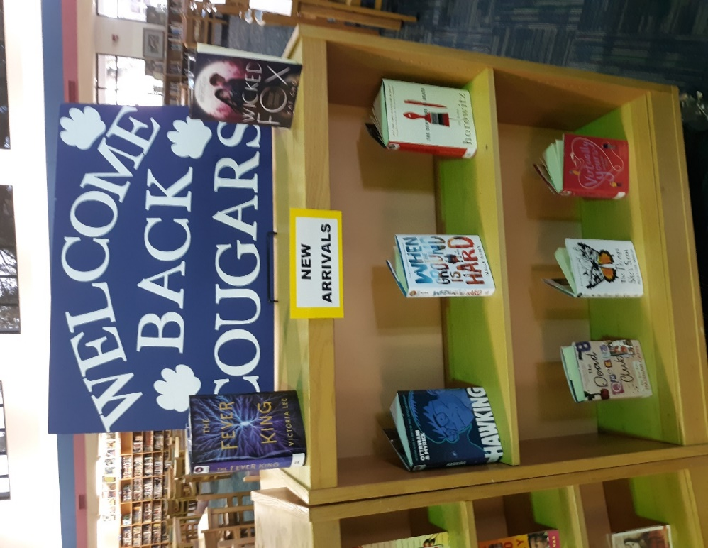
CURRENT STATISTICS AND HIGHLIGHTS!
Top 3 Circulated Books
- Batman: Nightwalker
Before he was Batman, he was Bruce Wayne, a reckless boy willing to break the rules for a girl who may be his worst enemy. This second novel in the new DC Icons series is penned by #1 "New York Times"-bestselling author Lu. The first printing of each DC Icons novel includes a limited-edition poster. Consumable.
- Flush
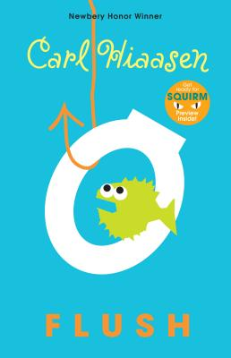
Noah's dad is sure that the owner of the Coral Queen casino boat is flushing raw sewage into the harbor--which has made taking a dip at the local beach like swimming in a toilet. He can't prove it though, and so he decides that sinking the boat will make an effective statement. Right. The boat is pumped out and back in business within days and Noah's dad is in the local lock-up.
Now Noah is determined to succeed where his dad failed. He will prove that the Coral Queen is dumping illegally . . . somehow.

- House of Ash
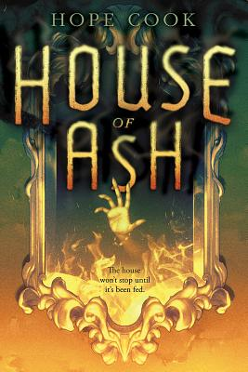
When seventeen-year-old Curtis begins hearing voices, he fears he is schizophrenic like his father, but soon he encounters Mila, a girl from the 1890s who lives in a cursed mansion and needs his help.

Total Number of Student ID Badges Created: 356
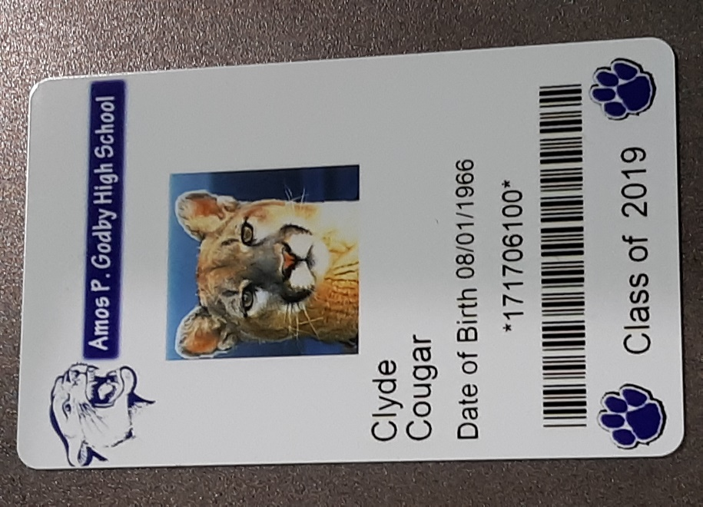

Total Number of Circulations: 657
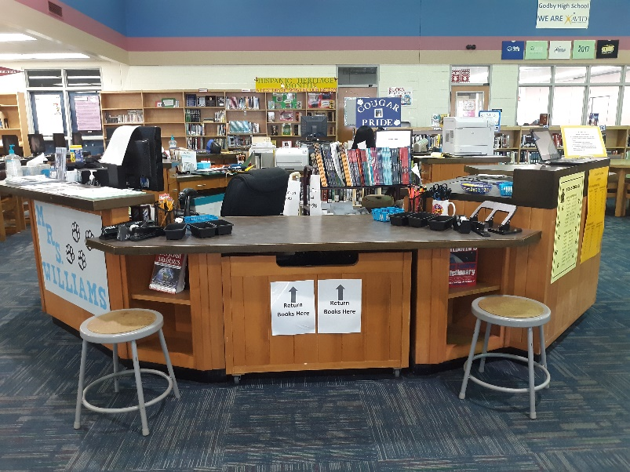

Grade level shout-out: Congrats 11th Grade for the most checked out books for First Quarter!
Teacher shout-out: Congrats Ms. Poey for the most students to check out books for First Quarter!

Student Sign-In By Day of Week

Total Number of Sign-Ins to Date: 889
Hispanic Heritage Month
Don’t know much about Hispanic heritage, culture, or traditions? Come by and check out our Hispanic book collection!
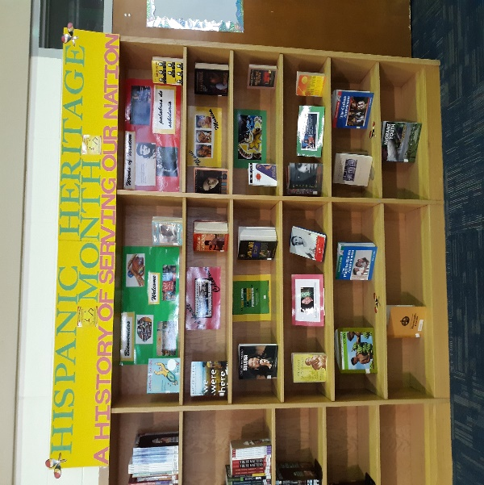
9-11-2001 Memorial
We shall never forget.
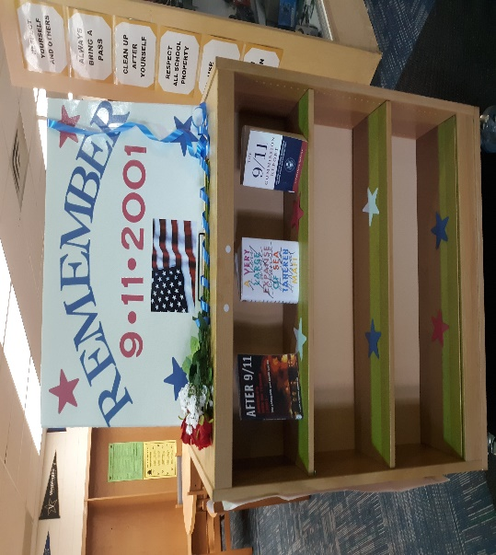
Cougarific Encouragement!
We advertise positivity and uniqueness in the Media Center because we want every student to know they matter and that they are capable of achieving anything they set their minds to.
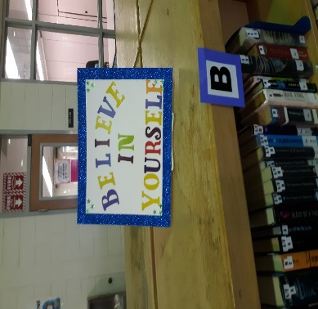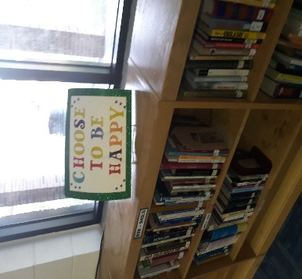
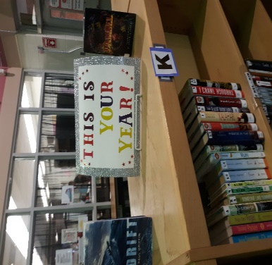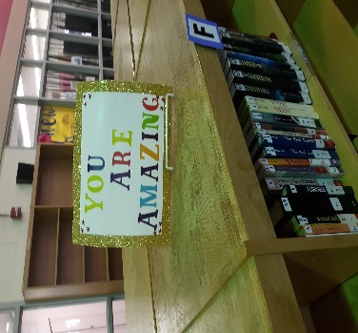
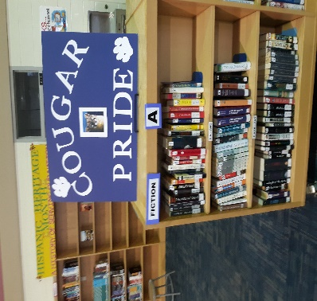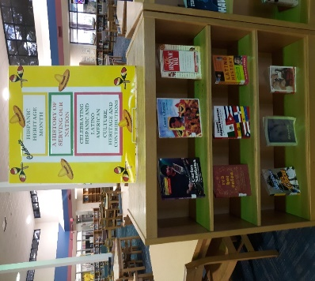
UPCOMING!
*Looking for researching tips/methods?
Gale Database whole class trainings will begin 2nd 9 weeks. (Email to signup: williamsl32@leonschools.net)
*Prepping for FSA, ACT, SAT, ASVAB, or another assessment? Considering a Vocational Career?
Cougar College and Career Corner will be set-up and ready to go during the 2nd 9 weeks. Feel free to stop by to check it out!

